Tab 1

## Merchant Name *: Glacier* Implementation POC: Royce *(IM to fill)* CX POC: *[IMP to Add]*

### 

### 

| Notes Sections   *(AE to fill if they have, Implementation to be completion DRI on handoff)*   * Info on how merchant bills * upfront fee paid on signing then a shipping and installation fee after a few months then pay another success metric fee once a machine hits a predefined success metric as defined in the contract  1) What is the merchant temperament? * Kind and open minded to other ways to structure their contracts and manage billing. All manual today just need help. Co-founder Areeb is college friend of Ali   3) What are the Tabs features that the key POC cares about?  Everything - they are moving off a master spreadsheet and need total automation and reporting |
| --- |

### Billing model *(Entire Section: Implementation to fill section)*

* Are there unique things about the customer creation process for this merchant?
* Information on how merchant bills
* How contract is broken up
* One off things to know about the merchant

### 

### Contract Processing Steps *(Entire Section: Implementation/Success to fill Post-Go Live)*

* **General**
  + Each customer agreement generally includes:
    - Down payments
    - Installation Fees
    - Setup Fees
    - Shipping
    - Hardware Purchase Fees (multi-year)
    - Software/Service Plan Fees (subscription model)
  + All BTs can generally be found under Exhibit A / the “Product Order Form” at the bottom of the contract

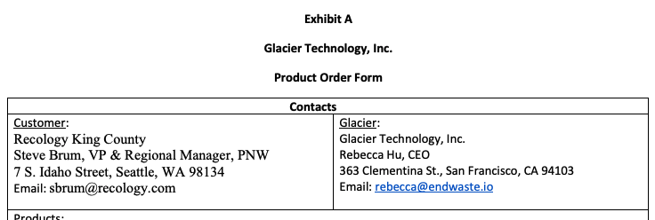

* + If the contract includes “For the avoidance of doubt” language regarding billing schedule, follow it directly.
  + For ongoing renewals (most contracts have this), extend software/service plan fees (subscriptions) by 3 years
    - This does not apply to Hardware or Scanner BTs
    - For example:
      * If Robot Service Plan Fees and Software Analytics Subscription Fees go annually for a 3 year period during the subscription period, add 3 to the # of periods and 36 months to the months of service
  + Please reference these examples
    - [#1](https://garage.tabsplatform.com/prod/contracts/3e1306ae-5bc6-432f-a146-641b72c1eb7e/preview)
    - [#2](https://garage.tabsplatform.com/prod/contracts/fb79ad6a-f8b5-46b3-8761-5ac90f1d6d05/preview)
    - [#3](https://garage.tabsplatform.com/prod/contracts/2ff9e77c-3325-46ae-8f53-6badbdd900bd/preview)
* **Item Name**
  + Use the labeled product title (this is typically *italicized* (e.g., "Robotic Hardware", "Robot Service Plan")
* **Item Description**
  + None
* **Quantity**
  + *Pay close attention* - if a BT price is “per” an event - for example, could be “per Robotic Hardware” - use the quantity provided in the contract for this event (e.g., QTY 2 for Robotic Hardware)
    - You can find this in the “Products” section table at the top of the order form
* 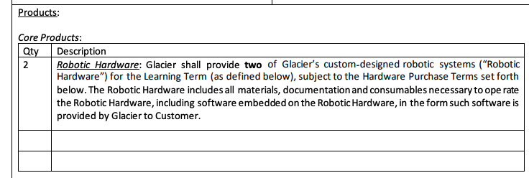
  + Default to 1 if no quantity is needed
* **Total Price**
  + If it is a “per” event BT, please multiple by the appropriate quantity
    - Example #1
      * “Robotic Hardware: Installment payments of $2,200 per month per Robotic Hardware”
      * QTY 2 for Robotic Hardware
      * Price should be $4,400 per month
  + Use net prices only, ignore discounts
  + Include $0 BTs if listed
* **Service Start Date**
  + Will be the contract effective date for most BTs
  + For the below BTs, it will be the date that it is delivered (billing start date)
    - Downpayment
    - Installation
    - Set up
    - Shipping
* **Months of Service**
  + Will be the same across the majority of BTs, except for the below. For the below, it will be 0 months
    - Downpayment
    - Installation
    - Set up
    - Shipping
  + For most contracts, you will take the “learning term” length add the “subscription term” length and if there is a renewal, add 3 years to that.

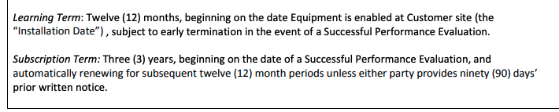

* + - For the above screenshot, months of service would be 12 + 36 + 36 = 84
* **Billing Start Date**
  + Follow the contract when it is explicit
    - For example, “Installation Fees: $150,000, payable by Customer on the *Effective Date.*”
  + When contract says “Purchase date,” we can assume this is 1 year after the effective date
    - For example, “Robotic Hardware: $25,000 per year per robot, payable annually starting on the Purchase Date and for a three (3) year term.”
    - We are assuming that purchase date comes at the end of the “Learning Term”
  + *Unless stated otherwise* -for contracts with scanner and hardware - assume scanner invoices are quarterly
  + Use these defaults if contract isn’t explicit about the start date
    - Downpayment: Effective date
    - Shipping: 30 days after effective date
    - Installation: 60 days after effective date
    - Hardware: 1 year after the effective date
    - Subscription and Service Fees: 1 year after effective date
* **Frequency**
  + Mostly either None or Annual
  + If a one-time payment, we can assume None
* **Net Terms**
  + If stated in the agreement (e.g., "due 30 days after invoice"), use that for each respective BT
  + Otherwise, default to 30
* **Reminders**
  + Always honor "For the avoidance of doubt" billing schedules if they exist
  + Pay close attention to the quantities in the Products table and how they affect total price

1. Anything to ignore in contracts?
2. Specifics processing things the merchant has requested that may differ by contract (e.g. always back-date invoice date to final day of the month)
3. How do we handle taxes as a line item?
   1. If None Listed, Ops Default is every tax line item becomes a BT

### Events Processing (if necessary) *(Entire Section: Implementation/Success to fill Post-Go Live)*

* Any important information on events billing

Integration Items Processing (if necessary)  
*(Entire Section: Implementation/Success to fill Post-Go Live)*

* What are the instructions for assigning integration items?
* Example: All Statsig integrations items should be labeled as “Sales”
* Example: All “Pinata” integration items should be labeled as “Software Subscription Bundle” unless otherwise noted by Merchant

Post Processing Communications (if necessary)  
*(Entire Section: Implementation/Success to fill Post-Go Live)*

* Does the Ops Team need to notify anyone on the team re: completion of processing batches in Implementation or Active phase?
* Who needs to be notified and when?
  + Example:
    - Who: Customer Success [Azmat Aziz] needs to be notified
    - Where: Messari internal merchant channel
    - When: contracts are processed [Merchant Phase: Active]

### Customer Information *(Entire Section: Implementation/Success to fill Post-Go Live)*

* Any important information on specifics customers of this merchant
  + Special memo’s certain invoices require
  + Invoice changes due to merchant/customer relationship

### Feature Requests *(AE to fill for all requests prior to Imp handoff, Imp to fill prior to go-live/Success to fill to fill Post-Go Live)*

* FR 1
  + What is it
  + Why it's important
  + Urgency

### Merchant Calls *(AE to fill for all videos prior to Imp involvement, Imp to fill prior to go-live/Success to fill to fill Post-Go Live)*

* Loom recording links by dates

Handover Notes

* Robots for recycling plants + software
* About to announce their raise, round A
* Co founder is Ali’s friend from college
* Ally is main point of contact (Chief of Staff and everything)
* Just working out of a spreadsheet right now
* 15 customers but high contract value
* Q: How long is their longest customer → Some have reached purchase stage
* They bill manually via stripe
* Needs more automation
* Milestone billing
* Savvy with google sheet
* West Coast team